LAPPING COST MODEL: AN EFFECTIVE TOOL TO CALCULATE FINISHING PROCESS COST

*Pankaj Singh Routela¹, Navdeep Malhotra² and Ashok Kaliyaperumal³
¹P.G.Student, ² Professor Department of Mechanical Engineering, YMCA University of Science & Technology, Faridabad, Haryana-121006.
³Manager, Department of DBS-SCPCM, Danfoss Industries Pvt. Ltd., SIPCOT Industrial growth center, Oragadam, Tamilnadu-602105.

ABSTRACT
In this paper, cost model for the lapping process is developed and used for analyzing the cost involved in this process. Lapping process was studied by means of experiments, literature survey and by visiting suppliers of the lapping machines. The results from the experiments, information from the suppliers and past experiments by the researchers were explored in details and used to develop the relations among potential parameters and to see the possibility of the lapping process cost model development. Cost analysis of the valve plate (a component of axial piston closed circuit pump) is also studied. A comparison between the results and the market price reveals the hidden savings potential in the process.

Keywords: Lapping, Machining cost, Value-based negotiation (VBN), Product Cost Management.

Introduction
Lapping can be defined as a low velocity and low-pressure finishing operation in which a small amount of material is removed from the workpiece (usually flat, cylindrical, or curved surfaces) by means of loose abrasive grains [1]. In lapping one or more parts are machined at the same time. The abrasive is usually mixed with a liquid vehicle, either oil or water based. The pieces being lapped are captured in retaining rings. Work holders also called "carriers" may be used to keep the parts separated and to prevent damage to their edges. The parts are dragged across the lap plate surface on to which the abrasive is being fed and with the cutting and shearing action of the abrasive particles. Removal of the material take place and renders a mat grey finish to the surface.

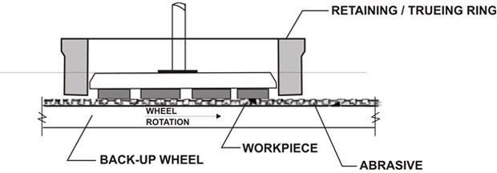

Fig. 1 Schematic diagram of lapping process [10]

Flat surface lapping or flat lapping is the most widely used type of lapping process. It is primarily used where extremely high flatness of the workpiece or close parallelism of double-lapped faces are required [2].

Several factors need to be considered during the lapping process. These include the type of machine, speed of the lap plate, type of material to be processed, pressure on the workpiece, material of the plate, type of abrasive, type of carrier fluid, abrasive to fluid ratio, size and shape of abrasive, time of operation and duration between the two consecutive instances of application of fresh abrasive slurry [3] In addition to the above aspects, there are some application-specific factors such as, skill of an individual lapper, environmental conditions, vibrations caused due to external sources, batch of abrasives, condition of the machine, and inherent variability within the workpiece. As a result, comprehensive models are difficult to create. Every individual lapper, based on his or her experience and skills must tweak the variables until the desired result is achieved. This may cost the company in large sums of consumables and enormous lost time [2].
Previous research has focused primarily on mechanisms of material removal and the effects of Input variables on material removal rate (MRR). But there are very few research papers which discusses in detail regarding the cost associated with the lapping process. As lapping process is most widely used finishing operation by the valve manufacturing and automotive companies, therefore, it is necessary to know about the exact cost associated with the process. Lapping cost model helps us in determining the cost, in creating benchmarking for the suppliers and in manipulating the cost of the newly developed or existing product.

*Corresponding Author - E- mail: Pankaj_routela@yahoo.com

Literature in lapping

W. Konig et al. (1996) observed that lapping speed is one of the working parameter with particular impact on obtaining small roughness surfaces with a superficial layer as little as possible affected thermally. Compared to other machining processes, lapping involves smaller speeds, between 20 and 150 m/min. for finishing, speed value ranges from 20-40 m/min. The excessive increase of the machining speed causes an overheating of the processed surface and diminishing its quality.
C.J Evans et al. (2000) stated that it is difficult (practically impossible) to directly observe the physical state of material removal processes in the polishing and lapping. Much of what we know about the fundamental mechanisms involved in the process has been derived either by extrapolation from experiments at scales which can conveniently be observed or by correlating macroscopic measurements of process outputs with models.
Justyna Molenda (2016) identified that the lowest and the highest Ra values i.e. 0.42 and 0.74 were obtained during lapping with smallest (F1200) and the biggest (F400) grains respectively and hence determined their applications for roughing (F400) and finishing (F1200) lapping operation. They found that when grain concentration and lapping pressure are constant, the number of active grains decreases with their dimension growth. As a consequence of higher load, single grain penetrates deeper into the workpiece surface.

Major Cost Drivers

While developing the cost model for the lapping process, major cost drivers include direct overhead cost, Indirect overhead cost, labor cost, set up cost and lapping slurry cost. The Architecture of the cost model for the lapping process is shown in Fig. 2.

Kuo-Yi Chang et al. (2002) observed that the carrier with circular holes produced a better surface roughness than those with rectangular or long strip holes in the lapping process. They also observed that the removal rate first increases, then decreases as the grain size increases and the surface roughness of the steel gauge block polishing using Al2O3 abrasive is smaller than that using SiC abrasive.
Lalit Suhas Deshpande et al. (2008) observed that abrasive wear due to ductile deformation was the predominant wear mechanism for stainless steel (S31600), while for bronze (C86300) suffered brittle failure (grain pull-out)and the wear due to ploughing (a type of abrasive wear mechanism) was the major cause of material removal. They had also mentioned that accuracy of lapping, especially the form accuracy at the edges was greatly affected by the use of different abrasives. With the increase in MRR, the rounding of the edges was observed to be increased too.
P.Deprez et al. (2009) in their experiments confirmed that machining productivity increases with speed. This increase in productivity is however not unlimited, with the increase in lap plate speed, the centrifugal forces also reache a value that can cause the abrasive slurry to be evacuated from the working area. Too high cutting speeds further affect the flatness of the machined surface, as a consequence, uneven distribution of the lapping paste in the working gap.
Walid Mahmoud shewakh (2012) identified that lapping process gives better surface than grinding in microscale, while in nanoscale the grinding process is better. Measuring direction also has an effect on the micro and nano surface roughness.

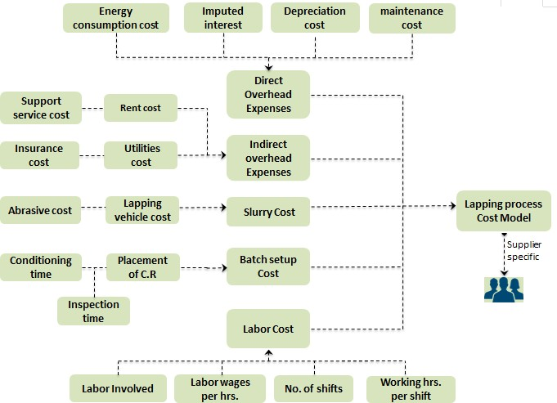
Fig. 2 Major cost drivers of the lapping cost model

Lapping Cost Calculations & Analysis
Cost analysis is basically implemented upon the lapping machine and the component at hand. For this cost model, a market research has been carried out to derive the technological advancements in the lapping machine. To develop the cost model for the process, Micro lapping machine of Model ML-36 high precision 3R single-sided flat lapping machine is analyzed and used for cost analysis. A setup of the machine is shown in Fig.3

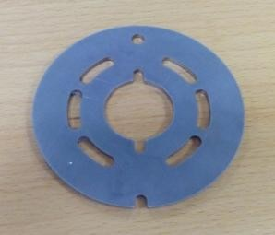

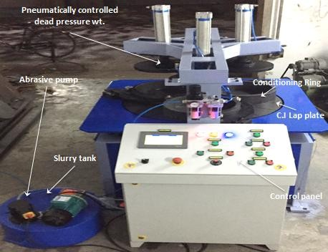
Fig. 3 Micro ML-36 lapping machine Table 1. Lapping Machine specification
Fig. 5 Valve plate

Direct overhead cost (DOH)

Direct overhead cost is the cost which is directly associated with the process or can be easily traced in a process or product. In lapping process, DOH includes
- Depreciation cost
- Energy cost
- Maintenance cost
- Imputed Interest cost

DOH = 3625.71 USD/yr. or 0.984 USD/hrs.

Depreciation cost= total machine cost/machine life
=1587.6 USD/yr. or 0.431 USD/yr.

Lapping process is very common and most widely used in finishing operations in Valve manufacturing and automotive companies. Therefore the component which is chosen for the cost analysis is Valve plate of material HMS 70 steel sintered with bronze and used in axial piston closed circuit pump.
Model No. | MLP-36
Machine type | Flat lapping m/c
Dia. Of lap plate (mm) | 915
No. of Conditioning Rings | 3
I.D of Conditioning Rings(mm) | 360
Load Applied (gm/cm^2) | 70-100
Lap plate Speed (RPM) | 58
Power Req. of Main drive  (K.W/H.P) | 3.728/5
Power Req. of Abrasive Pump  Motor (K.W/H.P),3 phase | 0.186/0.25
Machine dimension (LxBxH in mm) | 1220x865x1590
Price (USD) | 14000

Whereas,
Total machine cost = machine price + Installation cost Total Machine cost = 15876.0 USD
Machine price = 14000 USD Installation cost = 1876 USD Installation factor = 20% Machine Life = 10 Year

Energy cost = electricity rate x Machine power consumption x Annual earned hours
=1209.52 USD/yr. or 0.328 USD/hr.
Whereas,
Electricity rate = 0.0837 USD /KWh (India region) Machine power consumption = 3.914 KW
Annual Earned hours = No. of working days p.a x working hrs. Per shift x no. of shift x machine up time Annual earned hours = 3686.40
No. working days per annum = 288 No. of shift in a day = 2
Working hrs. Per shift = 8 Machine up time = 80 %
Maintenance cost = Machine price x Annual maintenance factor x purchasing power factor
= 469 USD/yr. or 0.127 USD/hrs..

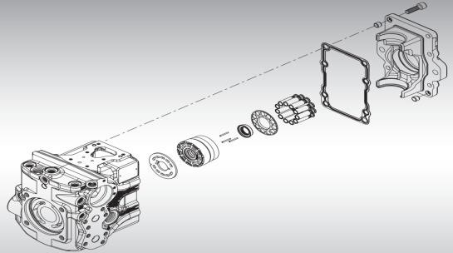Fig. 4 Axial piston closed circuit pump
VALVE PLATE
Whereas,
Annual maintenance factor = 5% Machine price = 14000 USD
Purchasing power factor = 0.67 (India region)

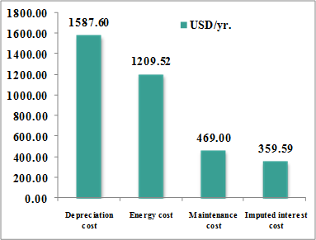

Fig. 6 DOH cost distribution in the lapping process

Imputed interest cost =Total machine price x imputed interest rate x salvage value factor
= 359.59 USD/yr. or 0.098 USD/hrs..
Whereas,
Total Machine cost = 15876.00 USD Imputed interest rate = 4.53% Salvage value factor = 50%

Indirect overhead cost (IOH)
Indirect overhead cost is the cost which is not directly associated with the process or a product. While developing this cost model, following IOH cost are considered.
Rent cost Utilities cost Insurance cost
Support service cost

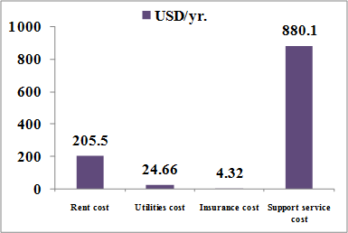
IOH = 1114.58 USD/yr. or 0.302 USD/hrs.
Rent cost
Rent cost generally associated with the space occupied by the machine and its value varies from region to region. The parameters required to calculate rent are as follows:
Rent cost = WorkCentre footprint x Rent rate (1 + Non- production foot print factor)
= 205.50 USD/yr. or 0.056 USD/hrs..

Work centre foot print = 3.17 m²
Machine length = 1220 mm (machine parameter) Machine width = 865 mm (machine parameter) Foot print allowance factor = 3
Rent = 49.94 USD/m² (For India region)

Utilities cost
Utilities cost associated with the facilities available in the company or working area. It includes
Electricity facility cost Water facility cost
Heat and gas facility cost
Utilities cost = 24.66 USD/yr. or 0.007 USD/hrs.. Electricity facility cost = Rent cost x facility electricity factor = 2.05 USD/yr.
Whereas,
Rent cost = 205.50 USD/yr Facility electricity factor = 1% water facility cost
Water facility cost = rent cost x facility water factor
= 2.05 USD/yr.
Whereas,
Facility water factor = 1%
heat & gas facility cost = rent cost x facility heat & gas factor
= 20.55 USD/yr.
Whereas,
Facility heat & gas factor = 10%

Insurance cost
Insurance cost is the cost which company is paying for the security purpose in case of some mishappening. It includes
Fire insurance cost Loss insurance cost Liability insurance cost
Insurance cost = Fire insurance cost + Loss insurance cost + Liability insurance cost
= 4.32 USD/yr. or 0.001 USD/hrs..
Fire insurance cost
Fire insurance cost = rent cost x fire insurance factor
= 0.21 USD/yr.

Fig. 7 IOH cost distribution in the lapping process
Whereas,
Fire insurance factor = 0.1% Loss insurance cost
Loss insurance cost = rent cost x loss insurance factor
= 2.05 USD/yr.

Whereas,
Loss insurance factor = 1% Liability insurance cost
Liability insurance cost = rent cost x liability insurance factor
= 2.05 USD/yr.
Whereas,
Liability insurance factor = 1%

Support service cost
Cost associated with support staff allocated to the work centre based on the fully burdened salaries of each department. It includes
Quality department cost Purchasing department cost Engineering department cost Tool crib department cost Maintenance department cost
Support service cost = Quality dept. cost + Purchasing dept. cost + Engineering dept. cost + Tool crib dept. cost
+ Maintenance dept. cost
= 880.10 USD/yr. or 0.239 USD/yr.
Workcentre capacity = No. of working days p.a x working
hrs. per shift x no. of shift per day
= 4608 hrs./year Quality department cost
Quality department cost = work centre capacity x quality support allocation x quality support rate
= 198.14 USD/yr.
Whereas,
Quality support allocation = 5%
Quality support rate = 0.86 USD/hr. (India region) Purchasing department cost

Purchasing department cost = work centre capacity x purchasing support allocation x purchasing support rate
= 220.49 USD/yr.
Whereas,
Purchasing support allocation = 5%
Purchasing support rate = 0.957 USD/hr. (India region)

Engineering department cost
Engineering department cost = work centre capacity x engineering support allocation x engineering support rate
= 351.59 USD/yr.
Whereas,
Engineering support allocation = 7%
Engineering support rate = 1.09 USD/hr. (India region) Tool crib department cost
Tool crib department cost = work centre capacity x Tool crib support allocation x Tool crib support rate
= 88.20 USD/yr.
Whereas,
Tool crib support allocation = 2%
Tool crib support rate = 0.957 USD/hr. (India region)

Maintenance department cost
Maintenance department cost = work centre capacity x maintenance support allocation x maintenance support rate
= 21.68 USD/yr.
Whereas,
Maintenance support allocation = 0.60%
Maintenance support rate = 0.784 USD/hr. (India region)

Labor cost

Labor cost is the cost associated with the no. of labors involved in operating the machine.it is calculated as follows
Labor cost per cycle = labor wages per hrs. x labor time
=0.2604 USD
Whereas,
Labor time = no. of Labor involved x process time x Lab. standard time
=0.4199 hrs.
No. of Labor involved = 1
Labor wages per hour = 0.62 USD/hr. (India Region) Process time (min.) =25.196
Lab. Standard time = 1

Lapping slurry cost

Lapping slurry consists of abrasives and lapping oil in the ratio of 1:4 and act as a cutting tool for the process. So the cost associated with the slurry is the cost of abrasive and lapping oil.
Lapping slurry cost = abrasive cost + lapping oil cost
= 21111.55 USD/yr. or 5.73
USD/hrs. Abrasive cost
In lapping process, 23 micron grain size alumina abrasive is used for the finishing operation and its daily consumption is approx. 5 kg.
Abrasive cost = abrasive consumption per day x cost of abrasive per kg x no. of working day p.a x machine up time
= 4430.592 USD/yr.
Whereas,
Alumina consumption per day = 5kg Cost of alumina per kg = 3.846 USD Lapping oil
Lapping oil = (4 x abrasive consumption per day/ density of the oil) x cost of oil per litre x working days
p.a x machine up time
=16680.96 USD /yr.

Whereas,
Density of the lapping oil = 0.85 g/cm³ Cost of oil per litre = 3.0769 USD

Batch setup cost
Batch setup cost is the cost required to run the machine for the whole batch in one shift. It includes checking the flatness of the plate, conditioning of the lap plate, placement of conditioning ring etc.
Batch setup cost per batch = setup time x (DOH + labor cost + IOH )
= 1.906 USD.
Whereas
Labor wages per hour = 0.62 USD/hr. (India Region) IOH per hrs. = 0.302 USD/hrs.
DOH per hrs. = 0.984 USD/hrs.

8.00
USD/hrs.
6.00
5.73
4.00
2.00
0.98
0.30
0.62
-
DOH cost IOH cost Slurry cost Labor cost

Fig. 8 Lapping process cost distribution

Cost Analysis Of Valve Plate & Validation Of Cost Model
Part name = Valve plate
Wt. of the valve plate = 166.8 gm Part dia. = ɸ92 ± 0.25 mm
Surface finish required (Ra) = 0.6 µ
Material removal rate (MRR) = 0.954 micron per min. Abrasive used = Alumina of grain size 23 micron Cycle time = 21 minutes
Process time = (loading+ unloading) x no. of part per cycle+ cycle time
= 25.196 min.
Loading and unloading time for one part = 0.55sec per kg x part wt. + 8.9 sec.
Part surface area = 6680.40 mm^2
Area available inside C.R’s (60% of Total area) = 63784.704 mm^2
No. of C.R’s = 3 Parts per cycle = 28
Annual volume = 50000 No. of batch = 12 Batch size = 4167
- DOH per part = (DOH per hrs. x process time)/part per cycle
▪ =0.0147 USD
- IOH per part = (IOH per hrs. x process time)/part per cycle
▪ = 0.00453 USD
- Labor cost per part = labor cost per cycle/part per cycle
▪ = 0.00929 USD
- Lapping slurry cost per part = (slurry cost per hr. x cycle time)/part per cycle
• = 0.0716 USD
- Batch setup cost per part = batch setup cost/batch size
• =0.000457 USD

Lapping process cost per part = 0.100577 USD
Lapping process exact cost per valve plate part = 0.11568 USD
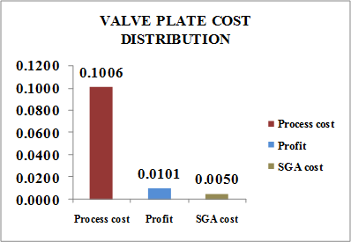

Fig. 9 Cost distribution of lapping process cost

- Selling goods & administrative (SGA) cost is 5% of the process cost
- Profit is 10% of the process cost

Conclusion
Machining cost value of the lapping process for valve plate comes out 0.11568 USD which is closed to the price quoted by the various suppliers and hence shows the correctness of the developed cost model. On the basis of this cost model, lapping process cost can be calculated for any mechanical component, which helps the design engineers to bring changes in their product design corresponding to the target cost of each component. Lapping cost per components also depends upon the annual production volume of the component and batch sizes.

References
- Le Xiaobin and Peterson M L (1999), “Material removal rate in flat lapping” Journal of Manufacturing Process, Vol.16(1), 71– 78.

- Lalit Suhas Deshpande, Shiv Kumar Raman and Owat Sunanta (2008), “Observations in flat lapping of stainless steel and bronze”, International journal of Science and Technology of friction, lubrication and wear, Vol.265, 105-116.

- Konig W and Klocke F (1996), Fertigungsverfahren 2 Schleifen, Honen, Läppen,” Machining Technologies, Grinding, Honing, Lapping, VDIVerlag, Düseldorf, Vol. 2.

- Evans C.J and Paul E (2000) “Material Removal Mechanisms in Lapping and Polishing”, CIRP Annals Manufacturing Technology, Zygo Corporation, Middlefield, USA.

- Chang Kuo-Yi, Song Yu-Hua and Lin Tsann-Rong (2002) “Analysis of Lapping and Polishing of a Gauge Block” International Journal of Advance Manufacturing Technology 20:414–419.

- Deprez P, Hivart P, Coutouly J F, and Debarre E (2009) “Friction and Wear Studies Using Taguchi Method: Application to the characterization of carbon-silicon carbide tribological couples of automotive water pump seals,” Advances in Materials Science and Engineering, pp. 1-10.
- Mahmoudshewakh Walid (2012) “Comparison between Grinding and Lapping of machined part surface roughness in micro and nano scale”, Journal of Mechanical Engineering and Technology.
- Molenda Justyna (2016) “Surface quality control of Al2O3 specimens after lapping”, Journal of KONES Powertrain and Transport, Vol. 23.
- https://www.gmt.co.in/archive/news-history-lapping.htm
- https://lappingmachinesindia.in/Lapping_Machines.html
- https://powersolutions.danfoss.com/products/piston-pumps-and- motors
- https://www.apriori.com/products/technology/virtual- production-environments/

